**Project Design Phase-II**

**Data Flow Diagram & User Stories**

|  |  |
| --- | --- |
| Date | 12 May 2023 |
| Team ID | NM2023TMID12015 |
| Project Name | AuditAI: A Machine Learning for Detecting Fraud in Audit Data |

**Data Flow Diagrams:**



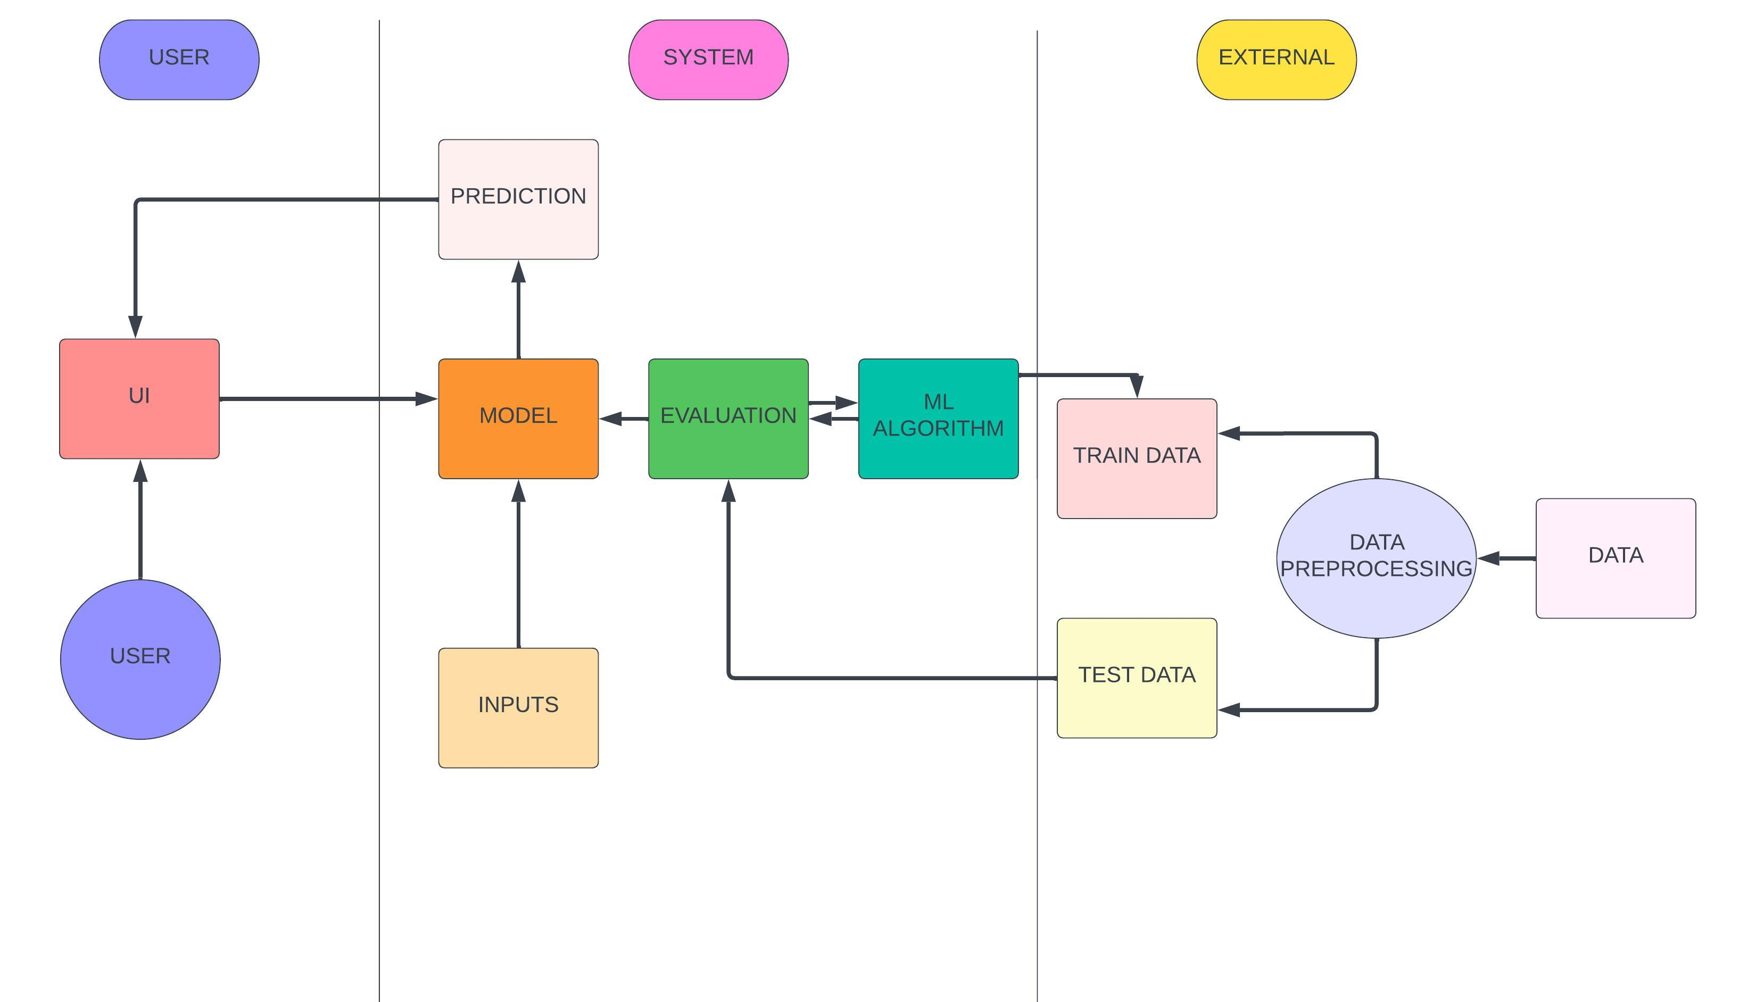

**User Stories**

Use the below template to list all the user stories for the product.

| **User Type** | **Functional Requirement (Epic)** | **User Story Number** | **User Story / Task** | **Acceptance criteria** | **Priority** | **Team Member** |
| --- | --- | --- | --- | --- | --- | --- |
| Customer (Mobile user) | Registration | USN-1 | As a user, I can register for the application by entering my email, password, and confirming my password. | I can access my account / dashboard | High | Sindhiya, Sharmila, Sugumar, Indira |
| Customer | Historical Data | USN-2 | Get the input from the user | Able to access the data after entering using proper username and password | High | Sindhiya, Sharmila, Sugumar, Indira |
| Customer | Analysis | USN-3 | Analysis the data by modifying as a model | Model the data after getting the structured data | High | Sindhiya, Sharmila, Sugumar, Indira |
| Customer | Train the data | USN-4 | Train the system with the historical data | Train the data when proper model is introduced | Medium | Sindhiya, Sharmila, Sugumar, Indira |
| Administrator | Maintaining | USN-5 | Maintain the data, for the analysis | When the Proper structured data is available | High | Sindhiya, Sharmila, Sugumar, Indira |